
Pupil premium and Catch up funding strategy statement: 2022-2025 Autumn ’25 review. (reviews in italics)
- Summary information
School | Dr Radcliffe’s CE Primary School
Academic Year | 2024-2025 | Total PP budget | 24/25 £17,455 | Date of most recent PP Review | Autumn 2025
Total number of pupils | 192 | Number of pupils eligible for PP | 10 | Date for next internal review of this strategy | Autumn 2026

2. Current Attainment 2022 | PP children (2022) | National all children (2022) | Reviewed for end 22/23 for 9 children still in school as at Autumn ’23. | Reviewed for end 23/24 for 8 children not in YR (23/24) still in school as at Autumn ’24. | Reviewed for end 24/25 for 10 children not in YR (24/25)
Percentage achieving age related expectations in reading | 33% | 74% | 78% at expected as at end 2022/23. | See Appendix 1  (each child 13%) | See Appendix 2 (each child 10%)
Percentage reaching age related expectations in Writing | 33% | 69% | 78% at expected as at end 2022/23. | See Appendix 1  (each child 13%) | See Appendix 2 (each child 10%)
Percentage meeting age related expectation in Maths | 67% | 71% | 78% at expected as at end 2022/23. | See Appendix 1  (each child 13%) | See Appendix 2 (each child 10%)

- Barriers to future attainment (for pupils eligible for PP including high ability)
In-school barriers (issues to be addressed in school, such as poor oral language skills) Identify barriers that need to be addressed in-school, as well as external issues such as poor home learning environments and low attendance)
 | Reading- being able to read fluently and with understanding
 | Writing- being able to construct an effective sentence.
C. | Maths- mastery of core curriculum
External barriers (issues which also require action outside school, such as low attendance rates)
D. | Social and emotional development- mental health and well-being

3. Outcomes (It is not essential to identify four desired outcomes; focusing on fewer aims in more depth is encouraged.)
 | Desired outcomes and how they will be measured | Success criteria
 | To read fluently and with good comprehension skills, using a range of strategies as appropriate to the age and stage | Passing the Year 1 phonics check/improved RWInc reading assessments  Achieving at least expected standard at the end of each year or improved progress scores  Improvements shown in PIRA results  Application of appropriate reading strategies including phonics to their reading  Age-appropriate language comprehension skills
 | To be able to construct sentences independently, using correct punctuation, accurate spelling and fluent handwriting as appropriate to the age and stage | Knowledge of phonics and other age-appropriate spelling patterns used in writing  Achieving at least expected standard at the end of each year or demonstrating progress in writing ages from NMM  Improvements shown in SWST results  Develop fluent handwriting
 | To be able to apply their mathematical knowledge to a range of number operation, place value and problem solving and reasoning questions independently. | Achieving at least expected standard at the end of each year or improved progress  Improvements shown in PUMA results
D. | Improvement in emotional skills | Improvement in self-esteem noted in class.  Improvement in the QCA scores if appropriate.  Improvement in strengths and difficulties questionnaire  Improvement in view of selves as a learner

Academic year | 2024-2025 Where (a) is indicated – it is a PP contribution towards a larger cost of that resource/intervention.
The three headings below enable schools to demonstrate how they are using the pupil premium to improve classroom pedagogy, provide targeted support and support whole school strategies.
- Quality of teaching for all
Desired outcome | Chosen action / approach | What is the evidence and rationale for this choice? | How will you ensure it is implemented well? | Staff lead | When will you review implementation?
To read fluently and with good comprehension skills, using a range of strategies as appropriate to a child’s age | RWInc phonics  Cracking comprehension  Reading for fluency  Wholes class/group guided reading sessions  SHINE intervention  Phonics professional development | EEF projects highlight the importance of language and literacy as building blocks for academic success and fulfilling careers and rewarding lives.  Phonics approaches have been consistently found to be effective in supporting younger pupils to master the basics of reading, with an average impact of an additional five months’ progress. Research suggests that phonics is particularly beneficial for younger learners (4−7 year olds) as they begin to read. Teaching phonics is more effective on average than other approaches to early reading. RWInc provides a structures and systematic approach to the teaching of phonics and has proven results.  Studies have shown that there may be additional benefits from being taught how to use comprehension strategies. Cracking comprehension builds on an approach in line with metacognition strategies as lesson are structured around modelling, guided practice and independent work.  Reading fluency supports the development of reading comprehension.  Whole class and guided reading enables children to practise reading fluency, comprehension skills, develops speaking and listening alongside the development of vocabulary. It enables some pupils to experience books that may not otherwise be their choice.  Use of Arch Reading Support with two children archoxfordshire.org | Observations and learning walks, test results and progress. Discussion with children.  Children reaching ae related expectations | To end Sum ‘25  Expenditure –  £915 (a) - development days, RWInc expenditure  £1,995 TA Reading Support  Arch Reading Support Fee £285 (a)  Accelerated Reader  £1000 (a)  Dyslexia assessments  £500  T - £4695 | December 2022, March 2023, July 2023  Autumn 2024  This review – Autumn 2025
Review for end 2024/2025: Guided reading sessions took place in. Nessy scheme used in Y3 for children who benefit from spelling/fluency/reading support and dyslexia. Dyslexia assessments. 1 phonics development day took place of RWI – including work with teachers to end Y2. Child who hasn’t passed re-take phonics to continue into Y3 interventions. One of two children who did not pass Y1 phonics in Yrs 1 and 2 now at ARE in Reading. Accelerated Reader now in place. For 25/26 T1 – (of 6 PP) 3 children Reading Age above Chronological Age and 2 children accelerated progress between 25 T1 and T2.
To be able to construct sentences independently, using correct punctuation, accurate spelling, and fluent handwriting as appropriate to the age and stage | Scheme of work for sentence level work  EEF guidance  Spelling- RWInc spelling Years 2 and 3  Spelling frame Year 4 and 5 (and Speling Shed Y6)  Handwriting | The EEF KS2 guidance report states that:  A fluent writing style supports composition because pupils’ cognitive resources are freed from focusing on handwriting, spelling, and sentence construction and can be redirected towards writing composition. Extensive practice, supported by effective feedback, is required to develop fluent transcription skills. Spelling should be explicitly taught and diagnostic assessment should be used to focus effort on the spellings that pupils are finding difficult.  Pupils should practise sentence-combining and other sentence construction techniques. | Moderation of  writing across school and using ‘no more marking’  Work scans  Lesson observations and learning walks  SWST spelling results  Children reaching age related expectations  NMM – No more marking. | FB  To end Sum ‘25  Expenditure –  Spelling/reading/Assessment Subscriptions  £300 (a)  NMM £200 (a)  TA Writing Support £1330  T - £1830 | December 2022, March 2023, July 2023  This review – Autumn 2025
Review: PenPals used for handwriting development.. Outcomes – 80% at Exp+ in Reading and GD higher in Writing. (NB – small cohort) Spelling results SWST – below chronological age 2/4 - the others above. Writing outcomes See below. 6 of 9 children with No More Marking data for 24/25 – writing age above their chronological age.

To be able to apply their mathematical knowledge to a range of number operation, place value and problem solving and reasoning questions independently. | NCETM maths scheme of work/mastery maths  SHINE intervention  Professional development | This resource provides coherent sequencing for the primary maths curriculum. It draws together the DfE guidance on curriculum prioritisation, with the high-quality professional development and classroom resources provided by the NCETM Primary Mastery PD materials. | PUMA results  Classroom observations  Progress in maths  Children reaching age related expectations | SG  To end Sum ‘25  Expenditure –  TA Maths Support £3325.00  BBO Maths Training  £100 (a)  T - £3425 | December 2022, March 2023, July 2023  This review – Autumn 2025
Total budgeted cost (A) |  |  |  |  | £9950
Review Professional development took place, largely through BBO Maths Hub (with associated cover costs). See below for Maths results – GD ahead of non – PP (NB Small cohort)

- Other approaches
Desired outcome | Chosen action/approach | What is the evidence and rationale for this choice? | How will you ensure it is implemented well? | Staff lead | When will you review implementation?
C To have an improved attitude to learning | Circle time  1:1 support as needed  Peer coaching  Recognition of achievements  Promotion of an activity that develops a positive view of self  Homework club | Research from the London schools shows that attainment is improved by improving the aspiration of young people. | QCA monitoring  Monitoring of attainment and progress  Feedback from children and staff in QCA audit. | JR £1050 (a)  Aut ‘25  Health related direct TA costs –  £ 3037  T - £4087 | 2023, July 2023  This review – Autumn 2025
QCA scores were completed at the beginning of the year. Where these are low they are reviewed through the year. Review – See QCA scores.
D. Improvement in emotional literacy | Play therapy  Teamwork for classes | Play therapy has been successfully running in school for about four years. It has been noticed to have a positive impact on the well-being of children.  Some children feel that they are on the outside of the class. In order to support the class emotionally, exploring this with the children should be beneficial. | Liaise with class teachers and play therapist  Discussion with class teacher | £2013 (a)  Aut’ 25 –  £300 (a)  ELSA supervision /training costs.  Residential Costs £1005  Y5 Mental Heath Lead costs £100 (a)  T - £3418 | 2023, July 2023  This review – Autumn 2025
Total budgeted cost (B) |  |  |  |  | £7505
Total Cost (A) plus (B) |  |  |  |  | £17455

Appendix 1

Attainment Comparison 23/24

NB Small cohort 8 of 192

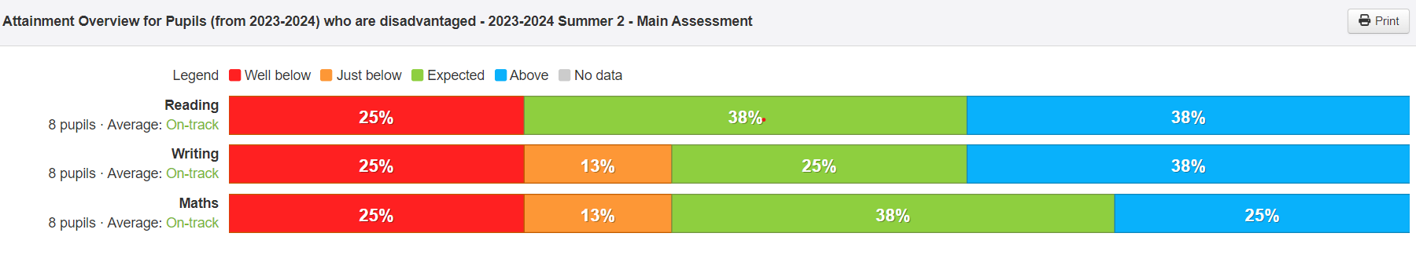

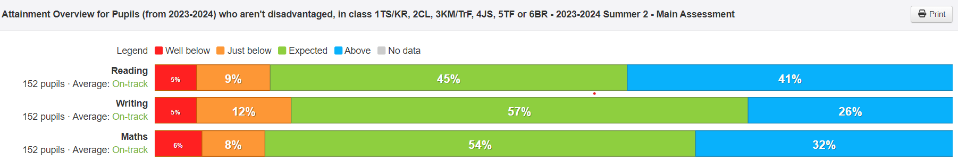

Appendix 2

Attainment Comparison 24/25

NB Small cohort 10 of 192



