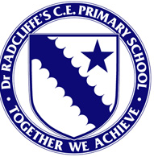

Dr Radcliffe’s CE Primary School

Curriculum Information

Music

Intent
Our high-quality music curriculum will engage and inspire pupils to develop a love of music and their talent as musicians, and so increase their self-confidence, creativity and sense of achievement.
Our Music lessons are planned using the Get Set 4 Music platform, which aligns with our core values, our whole child approach to Music and the objectives laid out in the National Curriculum. Get Set 4 Music is planned so that progression is built into the scheme which ensures our children are increasingly challenged as they move up through the school. The curriculum planning in Music is carried out in three phases (long-term, medium-term and short-term). The long-term plan maps out the Music topics covered in each term during the key stage. Our medium-term plans give details of each unit of work for each term. These schemes of work provide an overview of the unit, links to other areas of the National Curriculum and assessment criteria for that unit. The short-term lesson plans provide opportunities for children of all abilities to develop their musical skills, understanding and depth of knowledge by offering learning opportunities that build on pupils’ previous experiences.
- Pupils are given the opportunity to perform, listen to, review and evaluate music across a range of historical periods, genres, styles, cultures and traditions, including the works of the great composers and musicians.
- Pupils respond creatively to a range of music. They learn to sing and to use their voices, to create and compose music on their own and with others.
- They have the opportunity to learn a musical instrument and use technology appropriately.
- Pupils know that music is represented through notation
- Pupils understand and explore how music is created, produced and communicated, including through the inter-related dimensions: pitch, duration, dynamics, tempo, timbre, texture, structure and appropriate musical notations.
- They develop control in their compositions and their singing
- They are able to talk about music using musical vocabulary

Implementation
Each class will have regular music sessions taught by their class teacher or PPA teacher.
Music sessions will cover listening to music, rhythmic work, composition, improvisation and singing and will include playing tuned and untuned percussion instruments.
Children who play instruments will be encouraged to use their instruments in compositional work.
Year 2 and KS2 children participate in Worship through song every week for 20 minutes.
We have a weekly choir for KS2 children with opportunities to further their enjoyment of singing and perform on occasions throughout the year (Candlelight service, Harvest celebration, Easter, Pentecost service, summer concert).
Peripatetic music lessons will provide further opportunities for learning instruments more formally (Instruments include: ukulele, violin, piano, flute, trumpet and drums).
An orchestra will provide opportunity for children work on more formal music.
Partnership activities will enhance music provision.
Each class puts on a play during the year where children are given the opportunity to showcase their singing and music skills. Reception and Year 1 do a performance to parents at Easter which includes singing. Reception also does an End of Year performance to parents which includes singing.

Impact
By the end of KS2 we expect that pupils will be equipped with a range of skills to enable them to succeed in their secondary school and to be able to appreciate and enjoy music throughout their lives.
We expect that children will be confident performers, composers and listeners and will be able to express themselves musically at and beyond school. They will be able to play together cooperatively.
Children will show an appreciation and respect for a wide range of musical styles from around the world and will understand how music is influenced by the wider cultural, social and historical contexts in which it is developed.
We hope that children will understand the ways in which music can be written down to support performing and composing activities, will be able to demonstrate and articulate an enthusiasm for music and be able to identify their own personal musical preferences.
Finally, we expect that the children will be able to meet the end of key stage expectations outlined in the national curriculum for music.

Recording & Assessment

Our teachers assess the children’s work in Music through direct observation of children at work, questioning children or listening to their conversations. We also obtain photographs and recordings of some finished pieces. We have clear expectations of what the pupils will know, understand and be able to do at the end of each Key Stage. Teachers are supported with resources to know how to prepare children for their next phase of education. These resources include the Get Set 4 Music progression of skills and knowledge ladders and vocabulary pyramid.
At the end of each year teachers assess and record whether children are working towards, have met year group expectations or exceeded expectations in our assessment software Insights.

Music National Curriculum

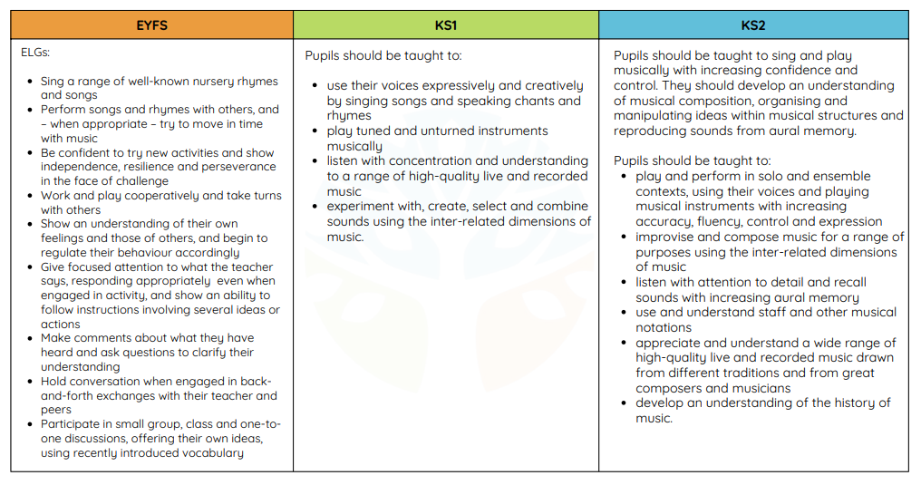

Long Term Curriculum Plan by Topic

Key Concepts running through the Curriculum:

Listening | Composing | Performing | Social | Emotional | Thinking

Further information on our Music Curriculum is available on our website at:
This includes:-
Progression documents
- Long Term Progression Map and year group unit overview.
- Notation, Composition, Listening and Performing progression ladders
Documents which may be of particular interest in supporting your child at home include:-
- Knowledge Organisers, which include activities to do at home.
- Vocabulary Pyramids, which contain relevant vocabulary by area and year group.
If you have any further queries on Music or wider provision for your child, please contact the school office on office.3828@dr-radcliffes.oxon.sch.uk

